**EXERCISE: 10**

**DATE: 22.11.2020**

**AIM:**

To write a Python function that accepts a string and calculate the number of upper-case letters and lower-case letters.

**PROGRAM:**

def string(s):

d={"upper_case":0,"lower_case":0}

for c in s:

if c.isupper():

d["upper_case"]+=1

elif c.islower():

d["lower_case"]+=1

else:

pass

print("No. of Upper case characters:",d["upper_case"])

print("No. of lower case characters:",d["lower_case"])

s=input()

string(s)

Link:

<http://103.53.53.18/mod/vpl/forms/edit.php?id=325&userid=1787#>

Output:

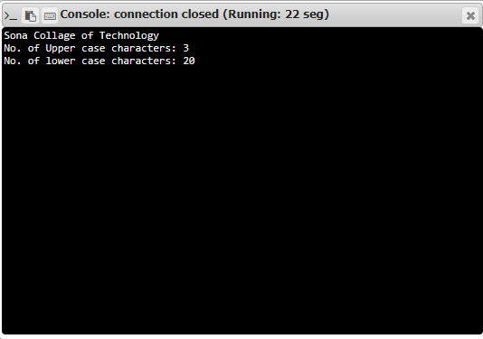

**RESULT:**

The number of upper-case and lower-case is calculated and displayed.